**Objective Questions & Answers:**

1. What is the total no. of tables present in the data?

**Answer: 2 tables**

Firstly, the raw data is converted into table format, by selecting on a cell and click on insert option. And click on the table, to create table with headers, by table design, we can make the table with different structures.

1. What is the total no. of attributes present in the data?

**Answer: 21**

All the column names in header are consider as attributes.

1. How many categorical columns are there in the data? [Search about categorical and continuous data, and try to answer this question]

**Answer: 14**

1. The data consists of some inconsistent and missing values so ensure that the data used for further analysis is cleaned.

**Answer:** Checking for blanks, find the blanks in cuisines column, selecting all data, apply filter with cuisines select blanks and remove the cell in row one after another.

1. Using the Lookup functions, fill up the countries in the original data using the country code.

**Answer:**  Insert a new column named as country and using VLOOKUP function. Fill the country name in the column.

=VLOOKUP([@CountryCode], Table3,2,0)

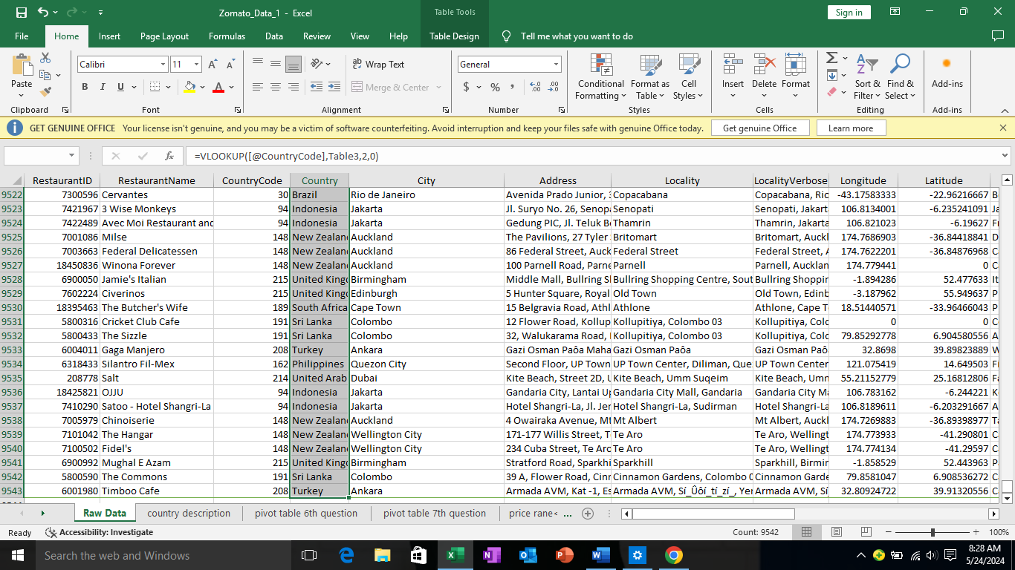

1. Create a table to represent the number of restaurants opened in each country.

**Answer**:

By using pivot table, need to create a table. Country in rows and count of restaurant ids in values.

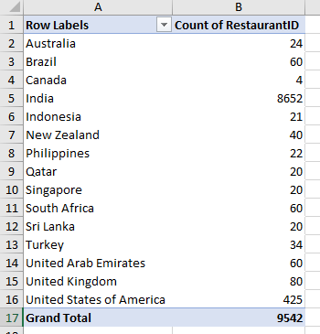

7.Also, the management wants to look at the number of restaurants opened each year, so provide them with something here

**Answer**: by using pivot table as rows in year and values by and count of restaurant ids…

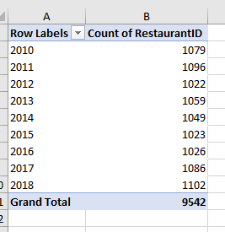

8.What is the total number of restaurants in India in the price range of 4?

**Answer**: 388

Used countifs, =COUNTIFS($D:$D,"India",$Q:$Q,"=4")

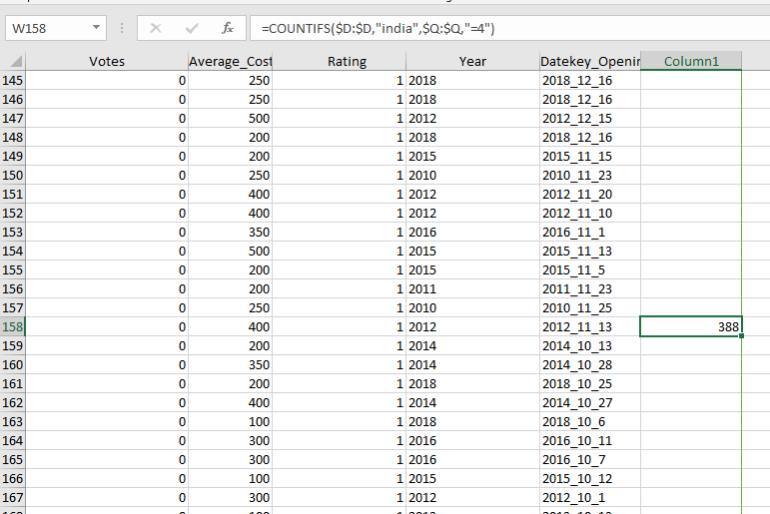

And also, we can find it in using pivot table. By filtering

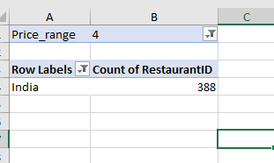

9.What is the average number of voters for the restaurants in each country according to the data?

**Answer**: using pivot table, country in rows and average of votes in values.

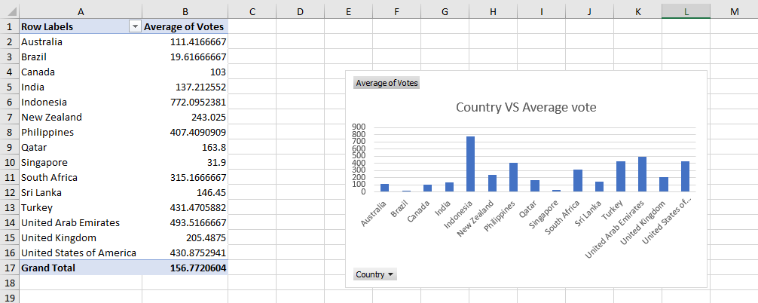

**10.** Calculate the average rating for all the restaurants that have price range < 4 and provide online delivery. Use only the “IF” function, Logical Operators, and Aggregation functions to solve this problem. **[Note: Don’t use Conditional aggregation in this question.]**

**Answer**: by creating new column,

* The below formula checks if price range (in Q2) is less than 4 and online delivery (in N2) is Yes.
* If both conditions are true, it returns the rating from Filter Rating; otherwise, it returns an empty string.

=IF(AND(Q2 < 4,N2 = "Yes"), U2, "")

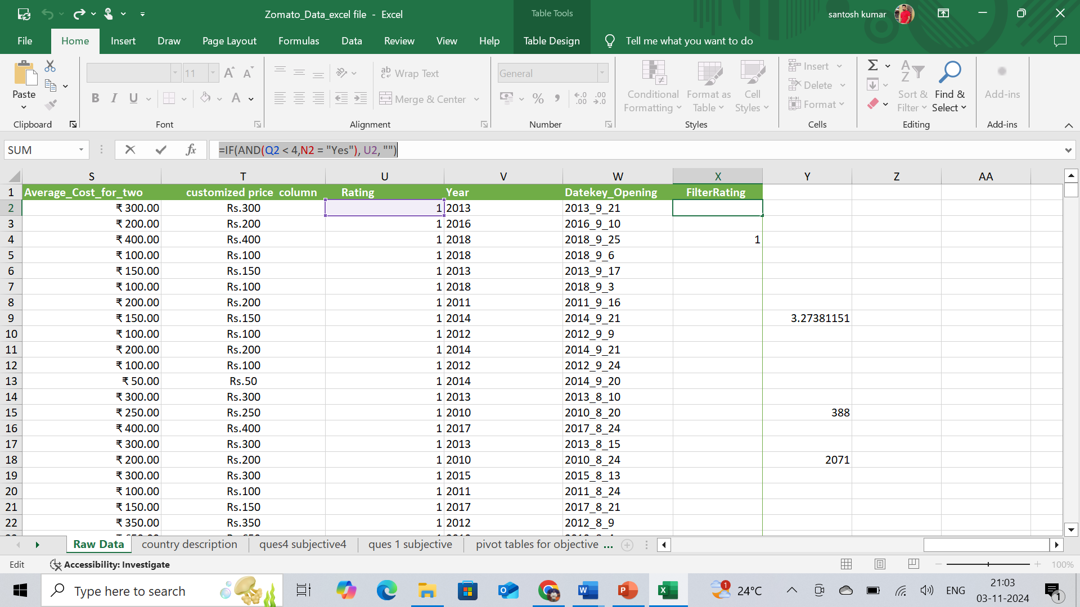

By using average from column Filter Rating:

= SUM($X$2:$X$9543)/COUNT($X$2:$X$9543)

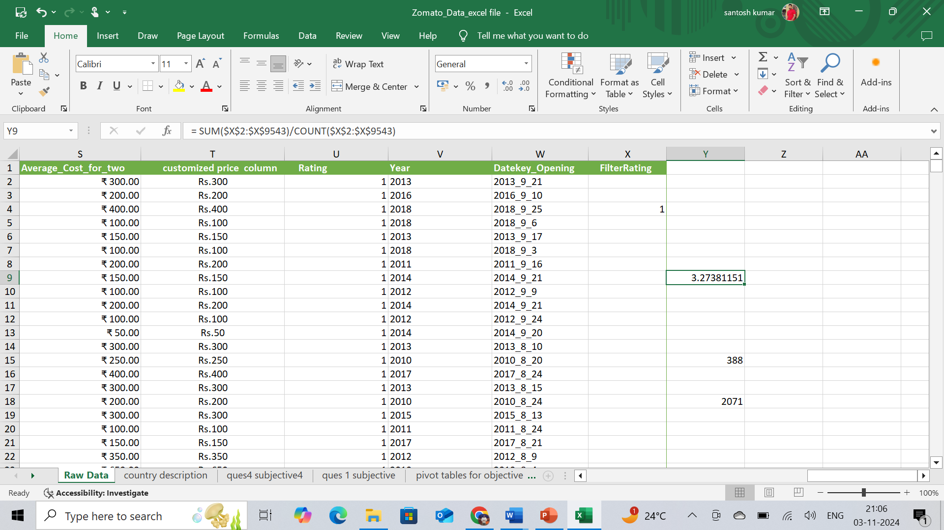

**The average rating for all the restaurants: 3.27381151**

11. Using Conditional formatting highlight the rows of restaurants that are located in the countries or cities that you’ve suggested to the management for opening new restaurants.

**Answer**: I used the below formula. And in the new rule for format color, I use blue to highlight the rows

= OR($C:$C = 14,$C:$C = 37,$C:$C = 148,$C:$C = 166,$C:$C = 184,$C:$C = 208,$C:$C = 214,$C:$C = 215)

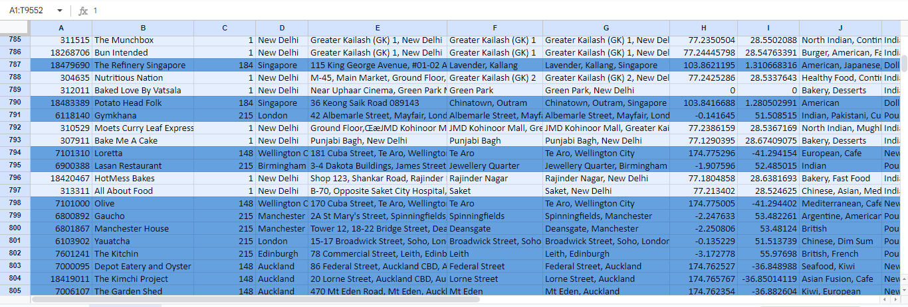

12. Create a new customized price column that consists of the abbreviation/symbol of the currency along with the Average_cost_for_two value. [Use string operations to do this task]

**Answer**: =(MID(L2,FIND("(",L2,1)+1,FIND(")",L2)-FIND("(",L2)-1))&S2

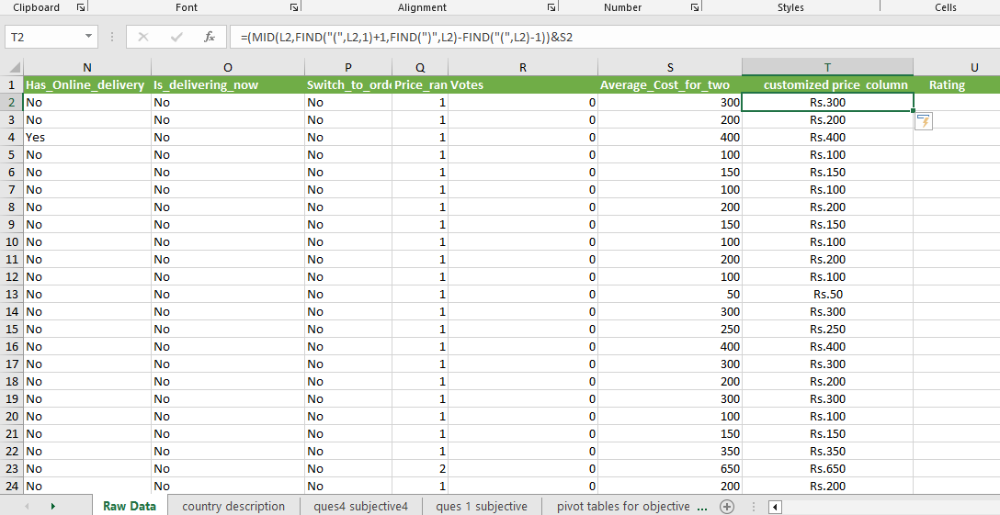

13. How can you create an array formula in Excel or Google Sheets to count the number of restaurants listed that do not offer online delivery, are in the lowest price range, and have an average cost for two people less than or equal to 250 Indian Rupees?

**Answer:**

* I have convereted the average cost for two column into single currency by using below for formula with INR VALUES.

**= S2 * VLOOKUP (L2,'INR Value'!$A$18:$B$29,2,FALSE)**

* The no of restaurants listed under above conditions using below formula and With array formula.

**{= COUNTIFS($N$2:$N$9543,"No",$Q$2:$Q$9543,"<3",$W$2:$W$9543,"<=250")}**

* The no of restaurants is: **1704**

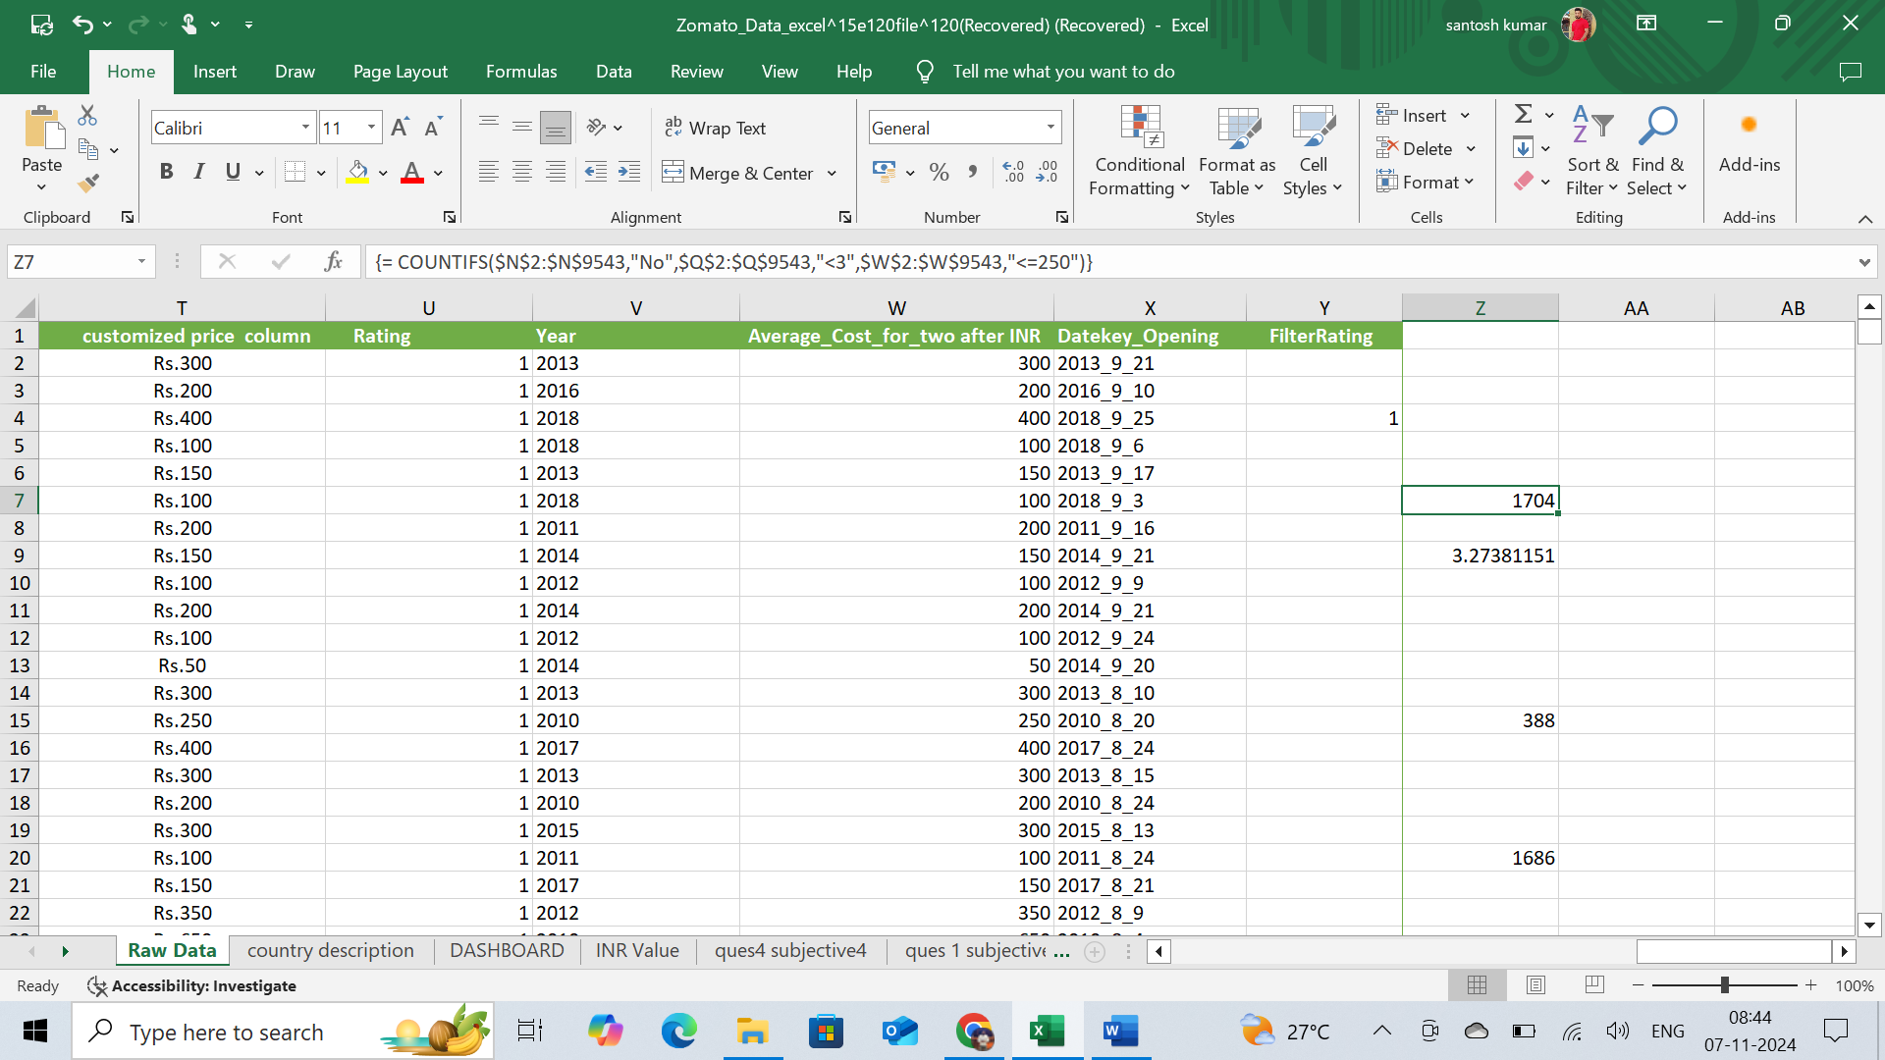

Subjective Question:

1. Suggest a few countries where the team can open newer restaurants with lesser competition. Which visualization/technique will you use here to justify the suggestions?

**Answer**: Australia

Canada

New Zealand

Qatar

Singapore

Turkey

United Arab Emirates

United Kingdom

The above suggested countries, they have below average no. of restaurants so there would be less competition, helpful in opening a new restaurant. These are based on average of average cost for two “<=5000” with their average rating >=3.5 and count of restaurant in between 20 to 80.

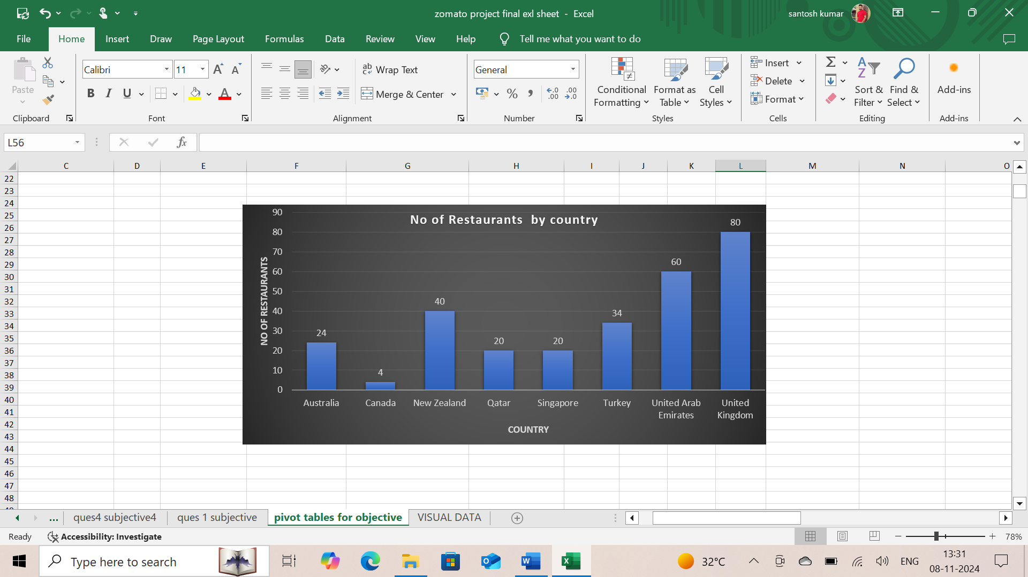

2. Come up with the names of States and cities in the suggested countries suitable for opening restaurants.

**Answer**: Name of the State or City:

|  |  |  |  |  |  |  |  |  |  |  |  |  |  |  |  |  |  |  |  |  |  |  |  |  |  |  |  |  |  |
| --- | --- | --- | --- | --- | --- | --- | --- | --- | --- | --- | --- | --- | --- | --- | --- | --- | --- | --- | --- | --- | --- | --- | --- | --- | --- | --- | --- | --- | --- |
| |  | | --- | | Abu Dhabi | | Ankara | | Auckland | | Beechworth | | Birmingham | | Chatham-Kent | | Dicky Beach | | Doha | | Dubai | | East Ballina | | Edinburgh | | Forrest | | Hepburn Springs | | Huskisson | | Inverloch | | Lakes Entrance | | London | | Lorn | | Manchester | | Middleton Beach | | Palm Cove | | Phillip Island | | Sharjah | | Singapore | | Tanunda | | Trentham East | | ÛÁstanbul | | Victor Harbor | | Wellington City | |

These are the states and cities name in the suggested countries who have rating “>=3.5” with price range of 1-3.

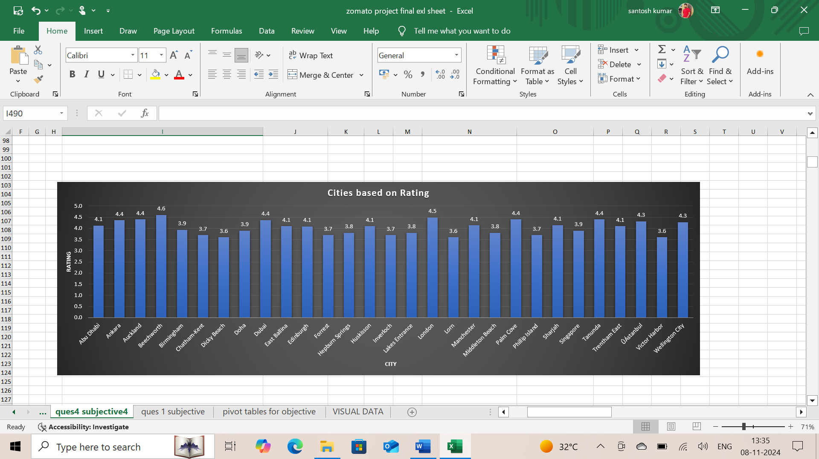

3. According to the countries you suggested, what is the current quality regarding ratings for restaurants that are open there?

**Answer**: The current quality of rating is “>=3.0”. for suggested countries

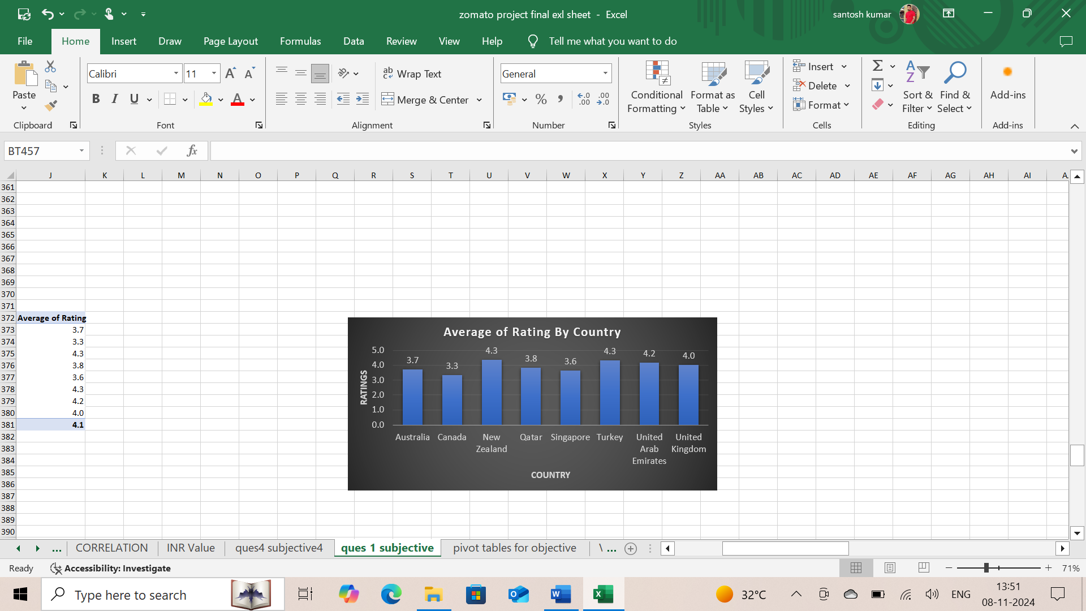

**Insights:**

* Calculating the average rating for each country, offering insight into the general quality perceived by customers.
* Compare these averages to identify which countries have higher-rated dining experiences overall.
* where customers are likely to experience the best-rated restaurants, the role of affordability in
* restaurant quality, and any unique trends observed in specific regions.

4. Also, what is the current expenditure on food in the suggested countries, so we can keep our financial expenditure in control?

**Answer**: The below Column chart is used to analyse the average cost for two vs each country to find the expenditure of the suggested countries

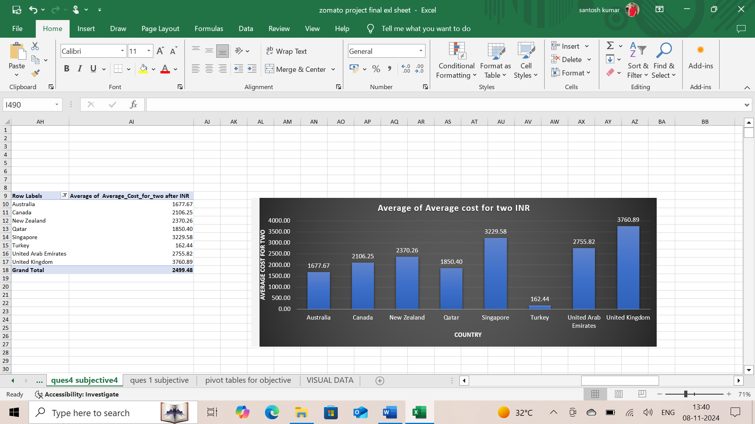

5. Come up with the names of restaurants from the recommended states that are our biggest competitors and also those that are rated in the lower brackets, i.e. 1-2 or 2-3.

**Answer**:

list of restaurants from recommended countries along with ratings

|  |  |
| --- | --- |
| 10 To 10 In Delhi | 3.8 |
| 1918 Bistro & Grill | 4.4 |
| 2 Dog | 4.2 |
| 3 Squares Diner | 3.4 |
| 306 North Restaurant | 3.9 |
| 5 Little Pigs | 4.1 |
| 7st by Mumbai Spices | 3.4 |
| A & A Pagliai's Pizza | 4.3 |
| A Dong Restaurant | 4.4 |
| Aôôk Kahve | 4 |
| Aalishan | 3.8 |
| Akbars | 4.2 |
| Al'frank Cookies | 4.2 |
| Almost Famous Burgers | 4 |
| Aloha Mixed Plate | 4.2 |
| Anchorage Cafe Restaurant Wine Bar | 3.6 |
| Antebellum | 4.3 |
| Applebee's | 3.8 |
| Archies | 3.4 |
| Archie's Waeside | 3.7 |
| Arigato Sushi | 3.3 |
| Artichoke Cafe | 3.2 |
| Artistry | 3.8 |
| Atlanta Highway Seafood Market | 4.9 |
| Atlas World Grill | 4.3 |
| Augsburg Haus | 3.9 |
| Austin's BBQ and Oyster Bar | 3.3 |
| Austins Cattle Co | 3.7 |
| Azteca | 4.3 |
| B Merrell's | 3.8 |
| B. Matthew's Eatery | 4.1 |
| Baduzzi | 4.6 |
| Bahama Breeze Island Grille | 4.3 |
| Bailey's Bar-B-Que | 4.1 |
| Baltazar | 4.3 |
| Bandit Burrito | 4 |
| Bank | 4 |
| Bao | 4.9 |
| Bar Estilo | 4 |
| Bar Gernika Basque Pub & Eatery | 4.3 |
| Barbacoa Restaurant | 4.1 |
| Bardenay | 4.5 |
| Barrett Junction Cafe | 3.3 |
| Beach Box Cafe | 3.7 |
| Beijing Cafe | 3.8 |
| BellaBrava | 4.1 |
| Benson's Steak and Sushi | 3.7 |
| Bentoya | 3.8 |
| Bern's Steak House | 4.7 |
| Berry Patch Restaurant | 4.3 |
| Bespoke Harvest | 3.7 |
| Biaggi's Ristorante Italiano | 4.1 |
| Big City Bread Cafe | 4.3 |
| Big Fish Eatery | 4.5 |
| Big Jud's | 4.2 |
| Bittercreek Ale House | 4.3 |
| Bitters & Love | 3.9 |
| BJ's Country Buffet | 3.3 |
| BlackStone | 4.1 |
| Bleu Cafe | 3.7 |
| Bleu Pub | 3.8 |
| Blue Bean Love Cafe | 3.8 |
| Blue House Cafe | 4.3 |
| Blue Orchid Thai Restaurant | 4.5 |
| Blue Point Grill | 4 |
| Bluebird Diner | 3.6 |
| Bob Roe's Pizza | 3.6 |
| Boca Kitchen Bar Market | 3.9 |
| Bocca Di Lupo | 4.5 |
| Bodega | 4.6 |
| Bodensee | 3.8 |
| Boise Fry Company | 4.4 |
| Boll Weevil Cafe | 3.9 |
| Bone Daddies | 4.6 |
| Bonefish Grill | 4.1 |
| Bosphorous Turkish Cuisine | 4.2 |
| Boufe Boutique Cafe | 3.2 |
| Bourbon Street Grille | 3.8 |
| Brick 29 | 4.4 |
| Bridge Road Brewers | 4.6 |
| Brown Bottle The Cedar Falls | 3.7 |
| Bubba Jax Crab Shack | 3.7 |
| Buckhead Bar and Grill | 4.2 |
| Buddy's Italian Restaurant | 3.7 |
| Buffalo Wild Wings | 3.4 |
| Burger Liquor | 4.1 |
| Burger Queen Drive In | 3.6 |
| Burnt Toast Cafe | 3.4 |
| Burt's Butcher Shoppe and Eatery | 4.3 |
| Butterburrs | 3.6 |
| Cactus Flower Cafe | 4.2 |
| Cactus Flower Cafe Navarre | 4.2 |
| Cafe Le Rue @ The Landings | 4.6 |
| Cafemiz | 4.4 |
| Caffe L'affare | 4.1 |
| Cafí© Tu Tu Tango | 4.6 |
| Cannon Brewpub | 3.9 |
| Carrabba's Italian Grill | 3.7 |
| Catfish Charlie's | 3.3 |
| Centro | 4.5 |
| Ceví_che Tapas Bar & Restaurant | 4.4 |
| Ceviche Tapas Bar & Restaurant | 4.25 |
| Ceviz AÛôacÛ± | 4.2 |
| Champps Americana | 3.5 |
| Chandlers Steakhouse | 3.9 |
| Chang Garden | 3.5 |
| Chaophraya | 4.166666667 |
| Chapala | 3.6 |
| Charley Noble Eatery & Bar | 4.3 |
| Cheddar's Scratch Kitchen | 3.7 |
| Chef Lee's Peking Restaurant | 4 |
| Chennai Dosa | 3.8 |
| Chick-fil-A | 3.7 |
| Chili's Grill & Bar | 3.8 |
| China Cafe | 4 |
| Chinoiserie | 4.4 |
| Choo Choo Eastside | 3.9 |
| Christian and Jake's Bistro | 4.4 |
| Chye Seng Huat Hardware | 3.7 |
| Civerinos | 3.7 |
| Clocked | 4.2 |
| Coconuts Fish Cafe | 4.5 |
| Colony | 3.8 |
| Columbia Restaurant | 4.4 |
| Conch Republic Grill | 4.5 |
| Consort Restaurant | 3 |
| Cool Basil | 4.1 |
| Coral - InterContinental Doha | 3.7 |
| Country's Barbecue | 4 |
| Court Avenue Brewing Company | 4.2 |
| Crust Stone Oven Pizza | 3.9 |
| Crystal Beer Parlor | 4.4 |
| Cut By Wolfgang Puck | 4 |
| Da Kao Restaurant | 3.8 |
| Daily Eats | 4.4 |
| Damascena Coffee House | 1 |
| Datz | 4.7 |
| De Fontein Belgian Beer Cafe | 2.3 |
| Dem Karakí_y | 4.5 |
| Deorio's | 4 |
| DePalma's Italian Cafe - Downtown | 4 |
| DePalma's Italian Cafe - East Side | 4.1 |
| Depot Eatery and Oyster Bar | 4.8 |
| Devotay | 4 |
| Dharma Blue | 4.1 |
| Dí_veroÛôlu | 4.3 |
| Diamond Thai Cuisine | 4 |
| Dishoom | 4.6 |
| DiVine | 3.4 |
| Django | 4.3 |
| Downtown Grill | 4 |
| Draft Gastro Pub | 4.9 |
| Dragonfly | 4.3 |
| Dub's High on the Hog | 4.4 |
| Duck & Waffle | 4.9 |
| Duck City Bistro | 3.7 |
| Duke's Waikiki | 4.4 |
| Earl of Sandwich | 4.7 |
| Eat at Thai | 4.6 |
| Eatopia | 3.9 |
| Eden Noodles Cafe Î__Î‡_†ƒ_†ƒ_¢ | 4.3 |
| Edison: Food+Drink Lab | 3.9 |
| Eggs 'n Things | 4 |
| Eight - The Langham Hotel | 4.7 |
| Ekim Burgers | 4.5 |
| El Cartel | 3.8 |
| El Cazador | 3.7 |
| El Fredo Pizza | 4 |
| El Herradero | 4.1 |
| El Jalisciense Mexican Restaurant | 4.1 |
| El Kiosco Mexican Restaurant | 4.2 |
| El Super Burrito | 4.1 |
| El Toreo Mexican Restaurant | 3.1 |
| El Vaquero Mexican Restaurant | 3.4 |
| Elements Coffee Co - Northwest | 3.4 |
| Ella's Americana Folk Art Cafe | 4.8 |
| Emilio's Cuban Cafe | 3.9 |
| Emirgan Sí_tiô | 4.2 |
| Enigma Cafe | 4 |
| Ethos Vegan Kitchen | 4.4 |
| Exotic India | 4.1 |
| Exotic Thai Restaurant | 4.1 |
| Famous Dave's | 3.6 |
| Farm To Fork | 4.3 |
| Farmhaus Burger | 3.9 |
| Federal Delicatessen | 4.6 |
| Fidel's | 4.4 |
| Fiesta Cancun | 3.6 |
| Fiesta del Asado | 4 |
| Fifth Street Bagelry | 3.8 |
| Filling Station | 4.1 |
| Fish Tales Lakeside Grille | 3.8 |
| Fisherman's Corner | 4.4 |
| Fisherman's Plate | 4.3 |
| Fishpatrick's Crabby Cafe | 3.2 |
| Five & Ten | 4.3 |
| Five Boroughs | 4.1 |
| Five Guys | 3.8 |
| Five Guys Burgers and Fries | 4.1 |
| Flat Iron | 4.9 |
| Flatbread Neapolitan Pizzeria | 4.6 |
| Flaxton Gardens | 3.5 |
| Floriditas | 4.2 |
| Flounders Chowder House | 3.9 |
| Flying Mango | 4.5 |
| Flying Pie Pizzaria | 4.1 |
| Fong's Pizza | 4.6 |
| Fork | 4.4 |
| Four Queens Dairy Cream | 3.9 |
| Frasers | 4 |
| Fratini La Trattoria | 4.1 |
| Frick's Tap | 1 |
| Friends Grille and Bar | 3.9 |
| Frog Hollow Tavern | 4.3 |
| Front Street Brewery | 4.3 |
| Fuji Bay Japanese Restaurant | 3.7 |
| Fuji Japanese Steak House | 3.9 |
| Fuji Japanese Steakhouse | 3.8 |
| Funkey Monkey | 3.8 |
| Gaga Manjero | 4.9 |
| Galleria de Paco | 3.6 |
| Gaucho | 4.5 |
| Gazebo | 4.4 |
| Giapo | 4.7 |
| Giovanni's Shrimp Truck | 4.5 |
| Giulios Greek & Italian Restaurant | 3.8 |
| Giuseppe's Pizza & Italian Specialities | 4.1 |
| Global Grill | 4.4 |
| Gokul Gujarati Restaurant | 4.3 |
| Golden China | 3.7 |
| Goldy's Breakfast Bistro | 4.5 |
| Goody's Deli | 3.8 |
| Goose Feathers Cafe and Bakery | 4.2 |
| Granite City Food & Brewery | 4.05 |
| Graze | 3.8 |
| Grecian Key Restaurant | 3.7 |
| Greek Corner Deli | 4.3 |
| Greek Village | 4 |
| Green Truck Pub | 4.7 |
| Grit | 4.2 |
| Guang Zhou Chinese Restaurant | 3.9 |
| Guido's Original New York Style Pizza | 4.3 |
| Gymkhana | 4.7 |
| Hakkasan | 4.8 |
| Handmade Burger Co. | 3.7 |
| Happy Joe's Pizza & Ice Cream | 3.5 |
| Hard Rock Cafe | 4 |
| Harvest Moon | 3.7 |
| Hattena Hatay SofrasÛ± | 4.6 |
| Hawg Wild BBQ & Catfish House | 4.1 |
| Hawkers Asian Street Fare | 4.6 |
| Hemingway's Island Grill | 3.5 |
| Henry Campbell's Steakhouse | 3.5 |
| Henry's | 4.1 |
| Hickory Park | 4.5 |
| Hippopotamus - Museum Hotel | 4.4 |
| Hofer's Bakery & Cafe | 3.9 |
| Hoka-Hoka Japanese Steak & Sushi | 4.4 |
| Hollerbach's Willow Tree Cafí© | 4.8 |
| Home Plate Grill | 4.2 |
| Home Sweet Home | 4.1 |
| Hong Kong Cafe | 3.6 |
| Hong Kong Chinese Restaurant | 3.8 |
| Houlihan's | 3.6 |
| Houndstooth Grill & Tavern | 4.4 |
| House of China Restaurant II | 3.8 |
| Huey's On The River | 4.1 |
| HuHot Mongolian Grill | 3.766666667 |
| Hula Grill | 4.3 |
| Hunan Palace | 3.8 |
| Hunter's Pub | 4.4 |
| Huqqa | 3.7 |
| I Am | 3.2 |
| íˆukuraÛôa SofrasÛ± | 4.4 |
| Ichiban | 4.3 |
| Ichiban Hibachi Steakhouse & Sushi Bar | 3.7 |
| Ike & Jane | 4.1 |
| Indian Coffee House | 3.4 |
| Ingleside Village Pizza | 4.9 |
| Irish Democrat | 4.4 |
| Istanbul Restaurant | 3.6 |
| J. Christopher's | 4.3 |
| Jaan | 3.8 |
| Jaco's Bayfront Bar and Grille | 3.9 |
| J'adore Chocolatier | 4.7 |
| Jamie's Italian | 4.033333333 |
| Jamjar | 3.1 |
| Jehova es Mi Pastor Tacos y Burritos | 3.7 |
| Jerry's Pizza | 3.8 |
| Jethro's BBQ | 4.3 |
| Jim Shaw's Seafood Grill & Bar | 4.6 |
| Jimmy Jack's Rib Shack | 4.2 |
| Jimmy's Pancake House | 4 |
| Jim's Burgers | 3.7 |
| Johnnie Mars | 3.9 |
| J's Homestyle Cooking | 3.6 |
| Ju Ju's Cafe | 3.7 |
| Kahill's Steak-Fish Chophouse | 3.5 |
| Kalmes Breaktime Bar & Grill | 3.6 |
| Karakí_y Gí_llí_oÛôlu | 4.7 |
| Kebap 49 | 4.3 |
| Kihei Caffe | 4.5 |
| Kimo's | 4.3 |
| Kiss Kiss | 4.3 |
| Kobe Hibachi & Sushi | 4.6 |
| Kona Brewing Company | 4.7 |
| L. May Eatery | 3.8 |
| La Dolce Vita Ristorante | 4.1 |
| La Favorita | 4.5 |
| La Jalisco Supermercato | 3.5 |
| La Trattoria of Lavandula | 3.8 |
| Lahore | 3.7 |
| Lake House Restaurant | 4.3 |
| Las Palmas | 3.8 |
| Lasan Restaurant | 4.1 |
| Last Resort Grill | 4.5 |
| Leman Kí_ltí_r | 3.7 |
| Leopold's Ice Cream | 4.6 |
| Little Penang | 4.4 |
| Little Sister Cafe | 4.5 |
| Liva | 3.4 |
| Locos Grill & Pub | 3.5 |
| Longhorn Steakhouse | 3.5 |
| Longstreet Cafe | 4.3 |
| Loretta | 4.2 |
| Los Agaves | 2.55 |
| Los Aztecas | 3.5 |
| Los Beto's | 4.4 |
| Los Pablos | 4.1 |
| Loudons Cafe & Bakery | 3.9 |
| Love Crumbs | 4.1 |
| Lucianos Italian Restaurant | 4.4 |
| Lulu's Chocolate Bar | 4.3 |
| Lulu's Waikiki | 3.9 |
| Machine Shed Restaurant | 4.1 |
| Mad Cowes Cafe | 3.7 |
| Maggiano's Little Italy | 4.4 |
| Mai Thai Restaurant | 4 |
| Mainland China Restaurant | 4.9 |
| Makansutra Gluttons Bay | 3 |
| Malo | 3.2 |
| Mama's Boy Restaurant | 4.5 |
| Mama's Fish House | 4.9 |
| Manchester House | 4 |
| Mandarin Chinese Restaurant | 4.5 |
| Manna Java World Cafe | 3.5 |
| Manuel's Bread Cafe | 3.8 |
| Maranui Cafe | 4.3 |
| Mario's Italian Restaurant | 3.6 |
| Mark's City Grille | 4.5 |
| Martin's BBQ | 4.2 |
| Marukame Udon | 4.9 |
| MasabaôÛ± | 4.2 |
| MasabaôÛ± Kebapí_Û±sÛ± | 4.2 |
| Masala Grill & Coffee House | 3.2 |
| Masala Zone | 4.1 |
| Masato Japanese | 3.9 |
| Mazzaro's Italian Market | 4.9 |
| McGuire's Irish Pub & Brewery | 4.9 |
| Meôhur í_zí_elik Aspava | 4.6 |
| Meôhur TavacÛ± Recep Usta | 4.5 |
| Mellow Mushroom | 4.25 |
| Meritage | 4.1 |
| Mi Patria | 4 |
| Miann | 4.9 |
| Midnight Espresso | 4.3 |
| Mikata Japanese Steakhouse | 3.6 |
| Miles Inn | 3.7 |
| Milse | 4.9 |
| Milwaukee Wiener House | 3.8 |
| Mimi's Bakehouse | 4.6 |
| Minerva's Food & Cocktails | 3.7 |
| Miyabi 9 | 4.8 |
| Miyabi Kyoto Japanese Steak House | 4.6 |
| Mom & Dad's Italian Restaurant | 3.7 |
| Mongo The Mongolian Fire Pit | 4.2 |
| Monica's | 3.8 |
| Monkeypod Kitchen by Merriman | 4.2 |
| Monolos Playhouse Restaurant | 3.3 |
| Montage | 3.6 |
| Monterrey Mexican Restaurant | 3.7 |
| Moon River Brewing Company | 3.7 |
| Moonie's Texas Barbecue | 4.1 |
| Mori's Japanese Steakhouse & Sushi Bar | 3.5 |
| Mother India's Cafe | 4.4 |
| Mr Cooper's House & Garden - The Midland | 4.2 |
| Mr. | 3.5 |
| Mr. Dunderbak's Biergarten and Marketplatz | 4.9 |
| MRA Bakery Sweets & Restaurant | 4 |
| Mrs. Wilkes' Dining Room | 4.5 |
| Mughal E Azam | 3.7 |
| Mughli | 4.5 |
| Mulligan's Brick Oven Grill | 3.6 |
| My Fathers Place | 3.7 |
| Nacho Mamas Burritos | 4 |
| NamlÛ± Gurme | 4.1 |
| Natalia's | 4.2 |
| Native Cafe | 4.2 |
| Nawaab | 3.9 |
| New Yorker Deli & Pizzeria | 4.6 |
| Nobu | 4.4 |
| Nosh Mahal | 1 |
| Nusr-Et | 4.1 |
| Oakwood Cafe | 4.9 |
| 'Ohana | 4.5 |
| Olive | 4.2 |
| Olive Tree Cafe | 4.6 |
| Ombra | 4.5 |
| Original Georgios Authentic Greek Food | 4.7 |
| Orleans | 4.1 |
| Osaka | 4.2 |
| Outer Limits Fun Zone | 3.5 |
| Paper Moon | 4.5 |
| Papouli's Mediterranean Cafe & Market | 4.2 |
| PappaRich | 4 |
| Passage 2 India | 3.8 |
| Peg Leg Pete's | 4.4 |
| Pepe's Piri Piri | 2.8 |
| Pepper Sprout Incorporated | 3.6 |
| Pho Bac | 4.1 |
| Pie Slingers Pizzeria | 4.1 |
| Pier 70 | 2.6 |
| Pig and Whistle | 4.1 |
| Pirates' House Restaurant | 3.8 |
| Pizza ÛÁl Forno | 4.7 |
| Poets Cafe | 2.4 |
| Pom Pom's Teahouse and Sandwicheria | 4.9 |
| Ponderosa | 3.6 |
| Portneuf Valley Brewing | 3.7 |
| Potato Head Folk | 3.1 |
| Prairie Grille at SteepleGate Inn | 3.4 |
| Punjab Restaurant | 3.8 |
| Purnell's | 4.5 |
| Rae's Coastal Cafe | 4.9 |
| Raglan Road Irish Pub and Restaurant | 4.3 |
| Rebos | 3.8 |
| Re-Cess | 4.2 |
| Red Ginger Sushi, Grill & Bar | 4.5 |
| Red Mesa Cantina | 4.6 |
| Red Mesa Restaurant | 4.5 |
| Restaurant Andre | 3.8 |
| Restaurant Gordon Ramsay | 4.7 |
| Rhinehart's Oyster Bar | 4 |
| Rhubarb Le Restaurant | 3.9 |
| Riverwalk Cafe | 3.6 |
| Rocks on the River | 4 |
| Rodeo Mexican Restaurant | 3.8 |
| Roka | 4.6 |
| Rookery | 4.5 |
| Roseleaf Bar Cafe | 4.7 |
| Roti & Boti | 3.9 |
| Roti Chai | 4.5 |
| Royal Hotel | 3.6 |
| Roy's | 4.2 |
| Rudy's Tacos | 3.6 |
| Rumba Island Bar & Grill | 4.6 |
| Rupes Burgers | 3.7 |
| Ruth Ann's Family Restaurant | 3.7 |
| Sabai Thai - The Westin Doha Hotel & Spa | 4.3 |
| Sakura | 3.8 |
| Sakura Sushi & Grill | 3.1 |
| Salsa's Mexican Restaurant | 3.4 |
| Salt Rock Grill | 4.2 |
| Samurai Japanese Cuisine & Sushi Bar | 3.6 |
| San Carlo | 4.25 |
| Sandpiper Restaurant & Lounge | 3.6 |
| Sansei Seafood Restaurant & Sushi Bar | 4.2 |
| Santos | 3.3 |
| Sconyers Bar B Que | 3.5 |
| Scratch | 3.7 |
| Seasons 52 Fresh Grill | 4.4 |
| Senor Iguanas | 3.6 |
| Shake Shack | 4.1 |
| Shenanigan's Irish Pub | 4.1 |
| Shige Japanese Cuisine | 4.1 |
| Shogun Japanese Steak House | 3.5 |
| Shokitini | 4.2 |
| Shorts Burger and Shine | 4.9 |
| Shot Tower Inn | 3.6 |
| Sierra's Mexican Restaurant | 3.9 |
| sketch Gallery | 4.5 |
| Sky On 57 | 3.4 |
| Smoke House BBQ and Catering | 3.8 |
| Smokin Gold BBQ | 3.9 |
| Smok'n Pig B-B-Q | 4.1 |
| Soho Hibachi | 4.3 |
| SOHO South Cafe | 4.3 |
| SOHO Sushi Bar & Deli | 3.6 |
| Solita | 4.9 |
| Southern Bliss Bakery | 3.7 |
| Sr. Sol 1 | 4.6 |
| Star Buffet | 2.9 |
| Star Noodle | 4.6 |
| Starbucks | 4.9 |
| Steak | 4.2 |
| Steel Magnolias | 3.8 |
| Stillwater on Belmore | 3.6 |
| Summer Pavilion | 3.9 |
| Sunshine Family Restaurant | 3.5 |
| Super Loco | 3.2 |
| Sushi Family | 3.6 |
| Sushi Thai Restaurant | 3.7 |
| Taco Bus | 4.5 |
| Tako Cheena by Pom Pom | 4.4 |
| Takosushi | 4.2 |
| Tantra Asian Bistro | 4.9 |
| Taqueria Del Sol | 4.1 |
| Taste of Balingup | 3.2 |
| Taste of India | 4.2 |
| Taste of India Nepal | 3.8 |
| Teacup | 4.1 |
| Texas de Brazil | 4.6 |
| Texas Roadhouse | 3.86 |
| Thai Garden | 4.2 |
| Thai Kitchen | 4.3 |
| Thai Moon Restaurant | 4.2 |
| Thai Paradise | 3.7 |
| Thai Pepper | 4 |
| Thatcher's Barbeque and Grill | 3.7 |
| The Artesian Restaurant | 3.6 |
| The Bee's Knees | 4.5 |
| The Belle General | 4.1 |
| The Bigos | 3.8 |
| The Black Cow | 4.3 |
| The Boozy Cow | 4 |
| The Breakfast Club | 4.5 |
| The Bridge | 3.6 |
| The Cafe | 4.9 |
| The Catch Seafood Room & Oyster Bar | 3.8 |
| The Chop House | 4 |
| The Coop | 3.6 |
| The Crab Shack | 3.95 |
| The Egg Factory | 4.3 |
| The Elephant House | 3.9 |
| The Fish House | 4 |
| The French by Simon Rogan - The Midland | 4.3 |
| The Garden Shed | 4.2 |
| The Giggling Goat | 3.6 |
| The Grand Marlin | 4.3 |
| The Grill | 3.7 |
| The Grill On The Alley | 4.4 |
| The Hamburg Inn No. 2 Inc. | 4.5 |
| The Hangar | 4.6 |
| The Hanging Bat | 3.5 |
| The Kimchi Project | 4.2 |
| The Kitchin | 4.4 |
| The Lady & Sons | 3.3 |
| The Lokal | 3.1 |
| The Machine Shed Restaurant | 3.8 |
| The Manhattan FISH MARKET | 4 |
| The Mellow Mushroom | 3.8 |
| The Moon Under Water | 4.1 |
| The Nacoochee Village Tavern & Pizzeria | 4 |
| The National | 4.1 |
| The Olde Pink House | 4.4 |
| The Plough | 4.2 |
| The Ravenous Pig | 4.4 |
| The Refinery | 4 |
| The Refinery Singapore | 3.2 |
| The Royal Peasant | 4.4 |
| The Screaming Eagle | 3.7 |
| The Taj of India | 4 |
| The Thai Bowl | 3.5 |
| The Tin Cow | 3.7 |
| The Warehouse Cafe | 3.8 |
| The Witchery & The Secret Garden | 4.1 |
| Theo Yianni's Authentic Greek Restaurant | 3.9 |
| Three Anchors | 3.8 |
| Tibby's New Orleans Kitchen | 4.7 |
| Timboo Cafe | 4.2 |
| Ting Thai Caravan | 4.1 |
| Ting's Red Lantern | 4.2 |
| Tipu Sultan | 4 |
| Tokyo Japanese Steak House | 3.9 |
| Tokyo Japanese Steakhouse & Sushi Bar | 3.9 |
| Tokyo Sushi | 3.7 |
| Tony Roma's | 3.3 |
| Tony's Italian Restaurant & Pizza | 3.7 |
| Tony's La Pizzeria | 3.6 |
| Transmetropolitan | 4.4 |
| Trappeze Pub | 4.2 |
| Trattoria Fresco | 4 |
| Trattoria Tiramisu | 4.1 |
| Triangle Restaurant | 2.4 |
| Troll Tavern | 2.2 |
| Tsing Tsao South | 4.1 |
| Tucanos | 4 |
| Tucks and Bao | 3.5 |
| Tu-Do Vietnamese Restaurant | 4.5 |
| Tuk Tuk Indian Street Food | 4 |
| Tursi's Latin King | 4.1 |
| Turta Home Cafe | 4.3 |
| Tuscan Oven | 4.1 |
| Uptown Vietnam cuisine | 3.3 |
| Valonia | 4.2 |
| Vic's On The River | 4.1 |
| Villa Gargano | 3.7 |
| Vince's Restaurant & Pizzeria | 3.6 |
| Vine - The St. Regis | 4.4 |
| Vinny Vanucchi's | 3.4 |
| Viva! Argentine Cuisine | 4.1 |
| Vivo Bar and Grill | 4.4 |
| wagamama | 3.7 |
| Wailana Coffee House | 4.2 |
| Walter's Coffee Roastery | 4 |
| Wasabi Sushi and Thai | 3.7 |
| Waterfront Seafood Market | 4.2 |
| Watershed Cafe | 3.7 |
| Whitebull Hotel | 3.5 |
| Winifreds | 3.7 |
| Winona Forever | 4 |
| Wood Stone | 4 |
| Woodfire Grille | 3.6 |
| Yard House | 4.6 |
| Yauatcha | 4.7 |
| Yellow Dog Eats | 4.9 |
| YÛ±ldÛ±z Aspava | 4.4 |
| Zaffran Dining Experience | 4.6 |
| Zaoq | 4.2 |
| Zen Japanese Steakhouse and Sushi Bar | 4.1 |
| Zigana Pide | 4.3 |
| Zoeys Pizzeria | 4.7 |
| Zombie Burger + Drink Lab | 4.2 |
| Zouk Tea Bar & Grill | 3.6 |
| Zunzi's | 4.5 |

Our biggest competitors into the recommended states which meet’s the condition of rating >= 4.8

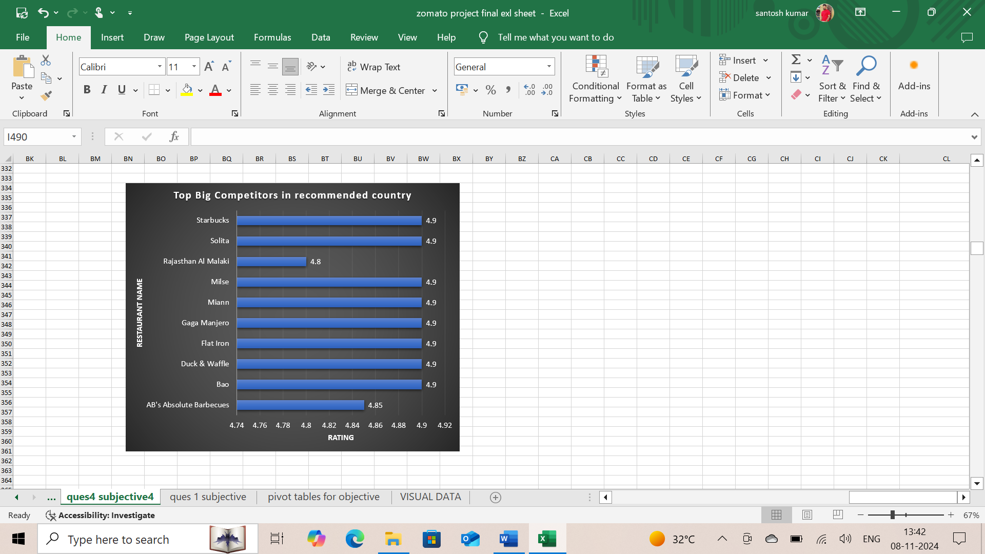

The restaurants that are in the lowest rating below 3 bracket :

|  |
| --- |
| Consort Restaurant |
| Damascena Coffee House |
| Makansutra Gluttons Bay |
| Pepe's Piri Piri |
| Pizza Hut |
| Poets Cafe |
| Star Buffet |

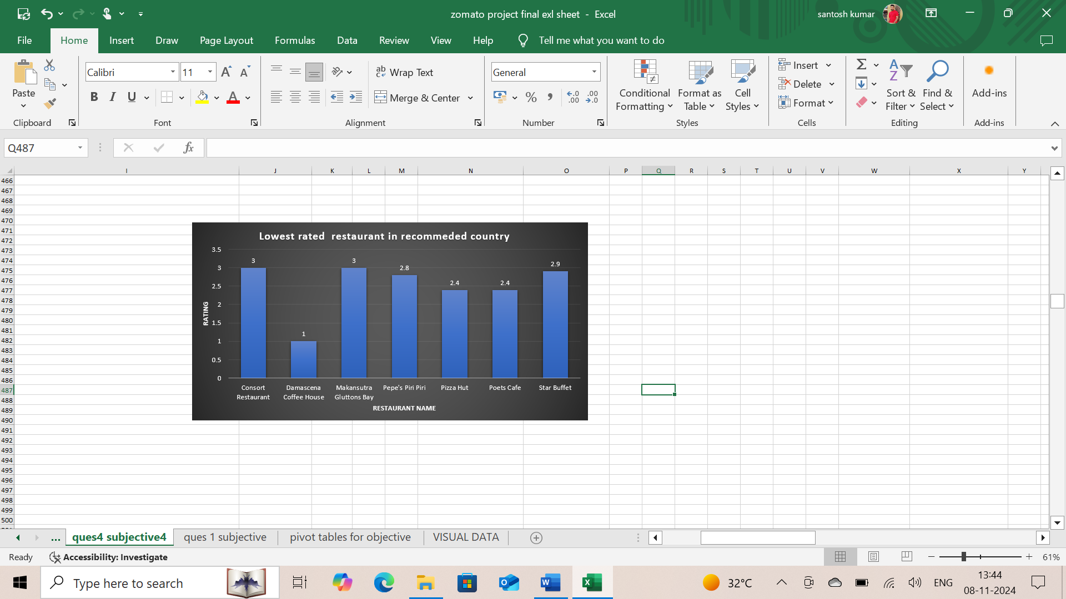

6. Which cuisines should we focus on in the newer restaurants to get better feedback? Does the choice of cuisines affect the restaurant ratings?

**Answer**: Cuisines to focus on:

|  |
| --- |
| American, Burger, Grill |
| American, Desserts |
| British |
| Cafe |
| Continental, Indian |
| Desserts |
| Desserts, Bí_rek |
| Ice Cream, Desserts |
| Indian, Continental |
| Indian, North Indian |
| Indian, North Indian, Curry, Cafe |
| Pizza |
| Scottish, Cafe |
| Steak |
| Taiwanese, Street Food |
| World Cuisine |

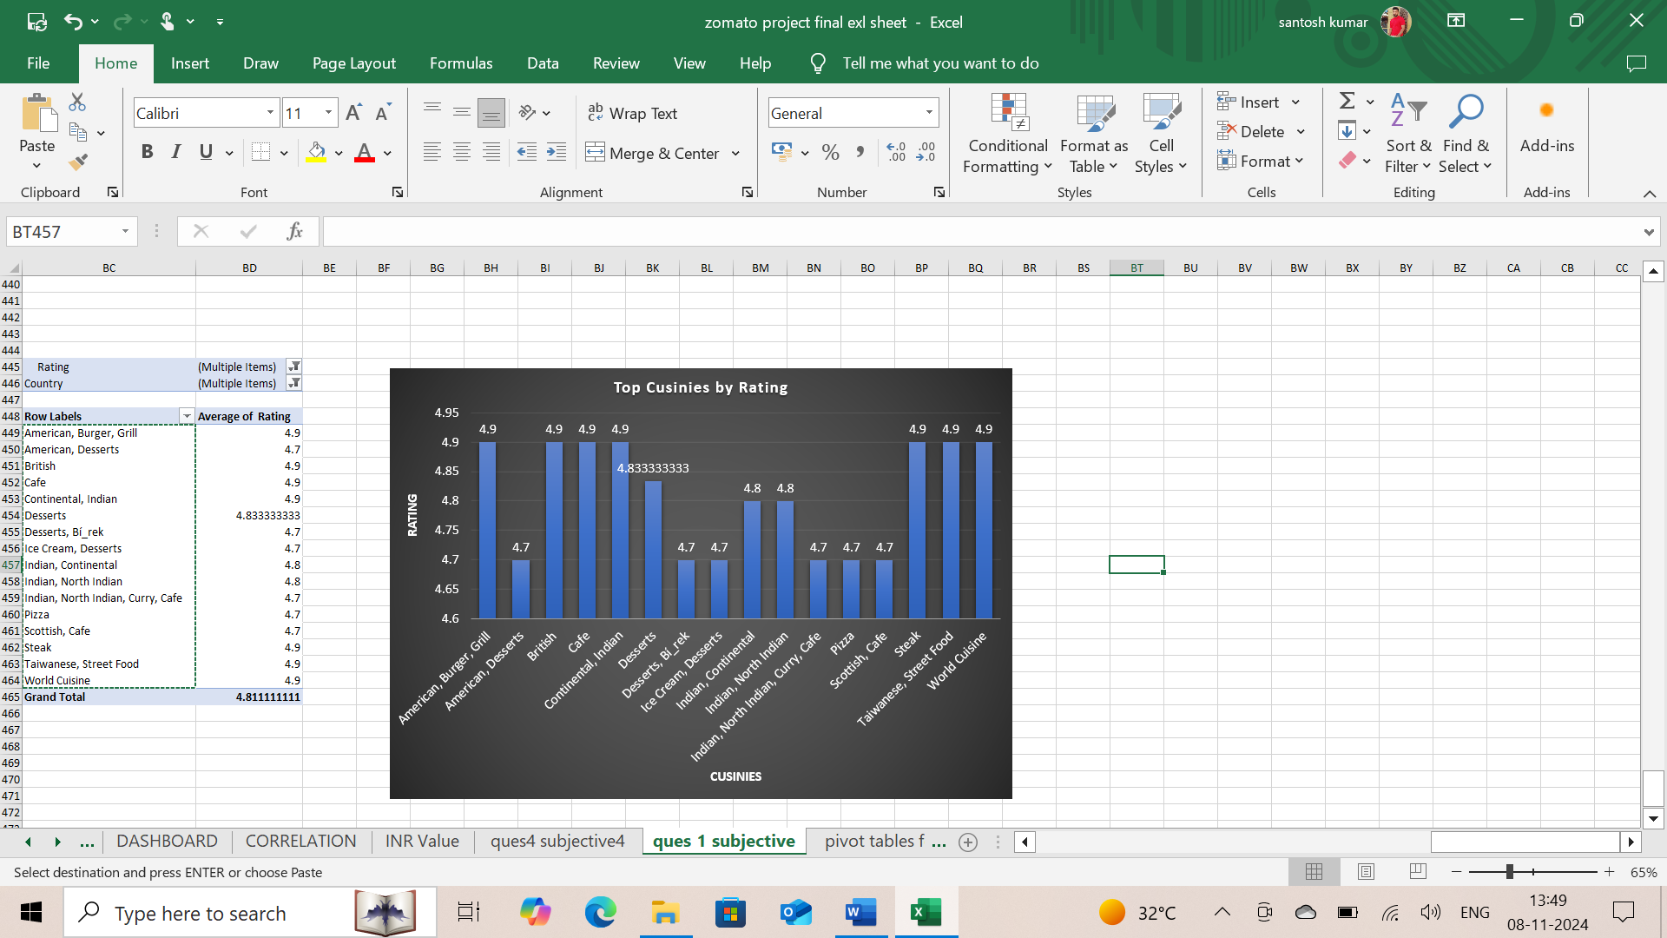

As per the screenshot we can see that the highest rating restaurant also has highest rated cuisines. So, we can draw the conclusion here that the choice of cuisine does affect the restaurant rating.

1. According to our current data, should we go for online delivery and table booking? Does that affect the customer’s ratings?

**Answer**: As per our current data, the recommended states have one country that is **United Arab Emirates** has online delivery system

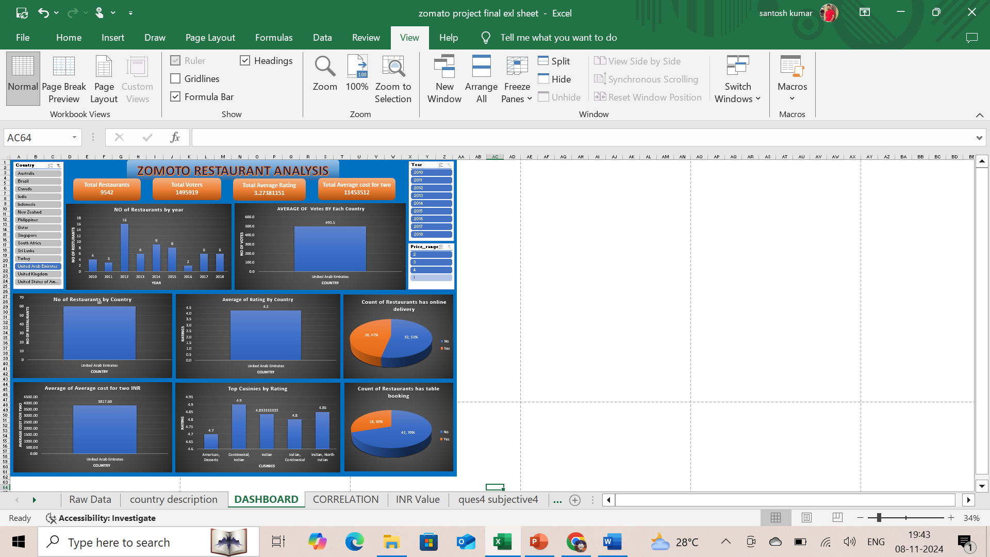

As per our data, we can see that there are only three countries that is “Quatar" & “United Kingdom” & “United Arab Emirates” where table booking is present.

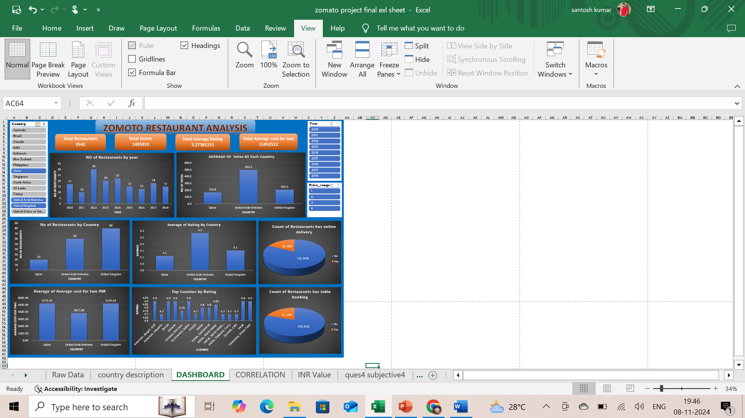

As per my observation, we can conclude that we can go for table booking in the countries where it’s already present i.e. Quatar & United Kingdom & United Arab Emirates. And for the other countries we could go for online delivery as there is one country where United Arab Emirates will be a good scope to capture the market. Online delivery is the primary business for ZOMATO.

1. Should the team keep the rate of cuisines higher? Will that affect the feedback? According to our data are the rates of cuisines and ratings, correlated?

**Answer**:

* Calculating Correlation Between “Ratings” and “Average Cost for Two”:
* Using formula = CORREL($A$2:$A$9543,$B$2:$B$9543)

0.312679 showing **Near-zero Correlation**

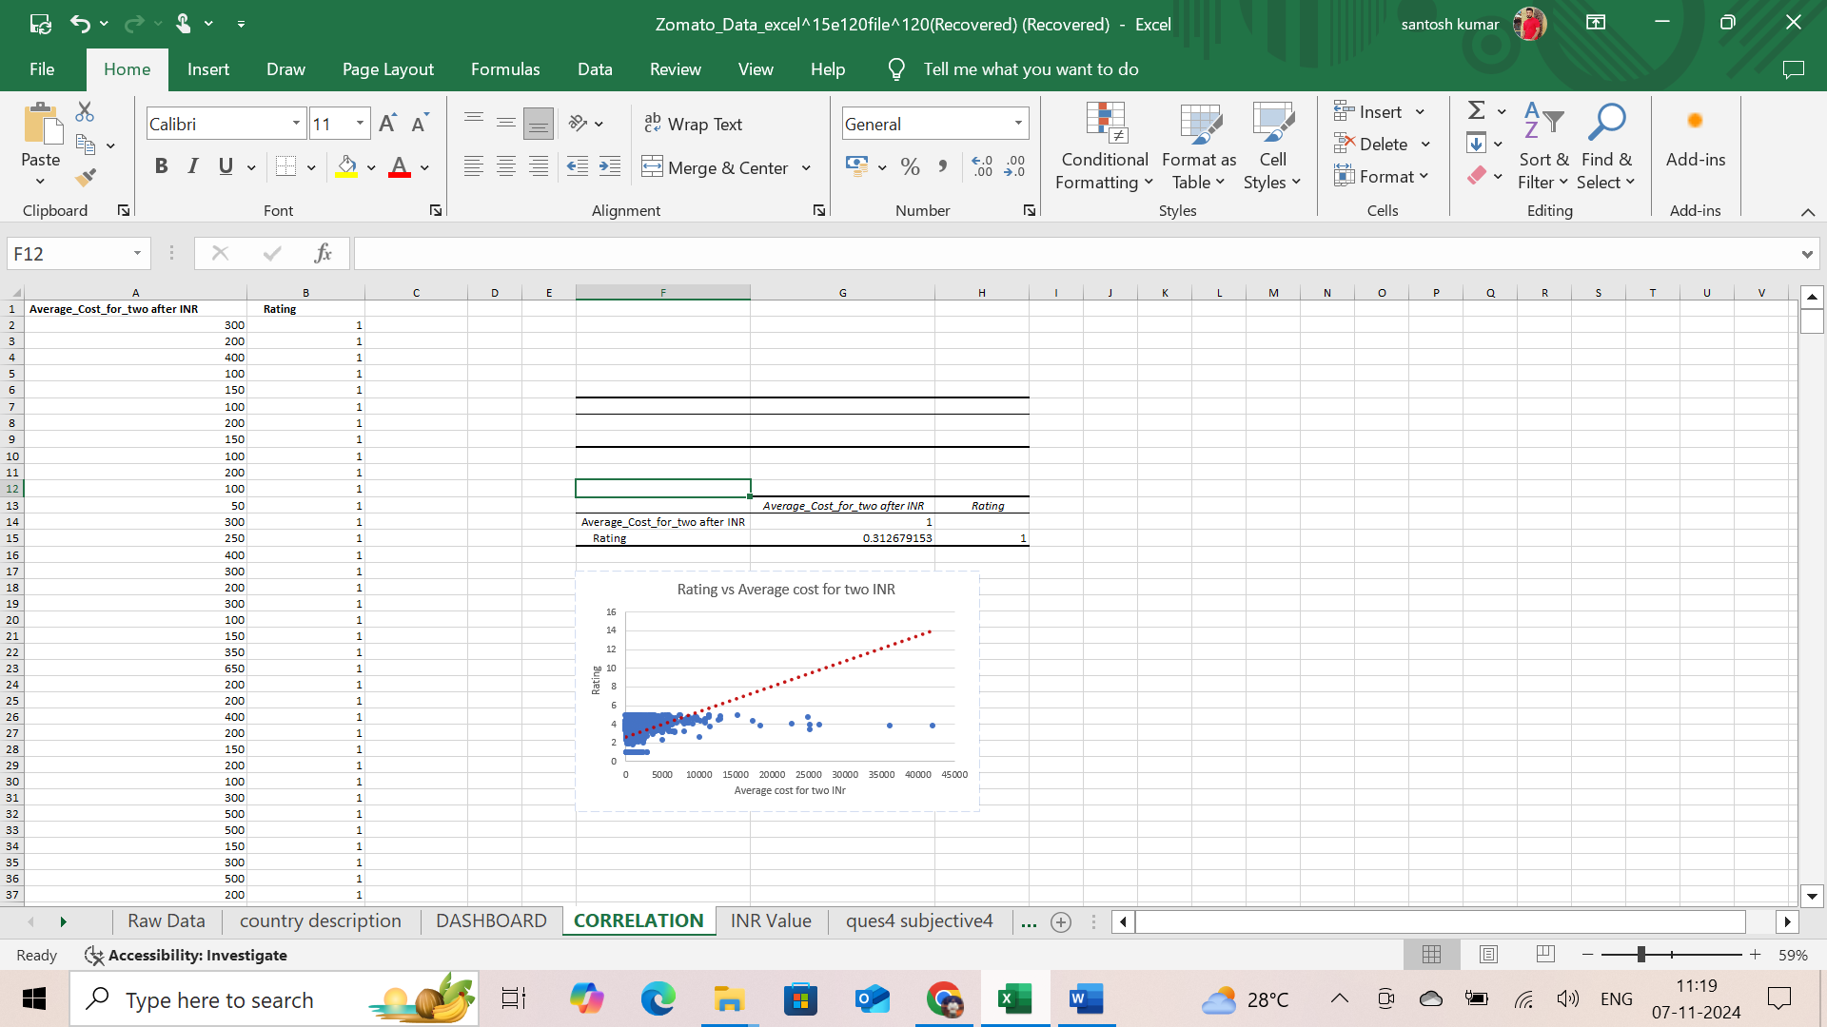

* the team keep the rate of cuisines higher, hence Correlation Between “Ratings” and “Average Cost for Two” showing **Near-zero Correlation**: Indicates little to no relationship. correlation.

1. What is the distribution of the number of restaurants of different price ranges in all the countries?

**Answer**:

**Price Range Of 1.**

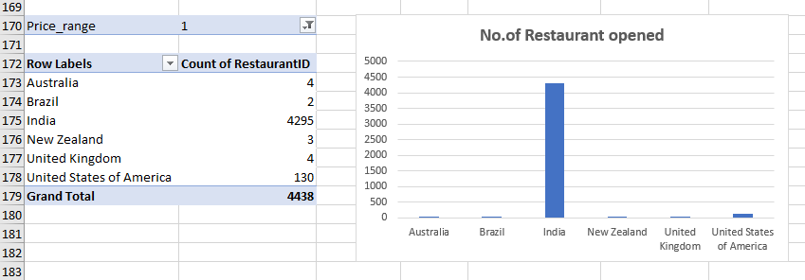

**Price Range Of 2.**

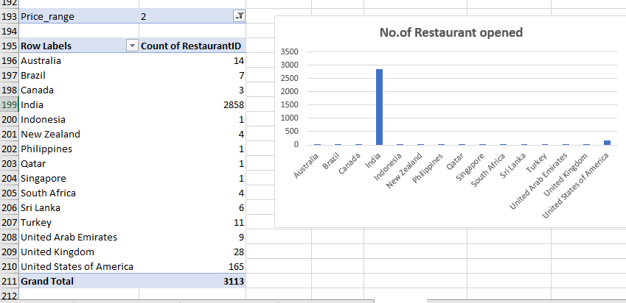

**Price Range Of 3.**

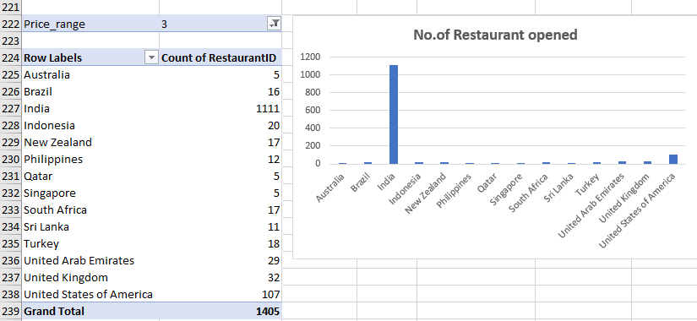

**Price Range Of 4.**

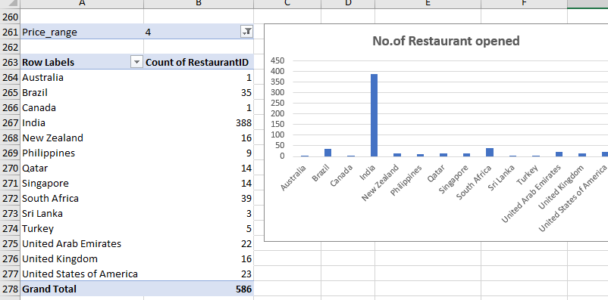

10. Explain your approach in brief for suggesting countries/cities in order to open new restaurants, if the objective and subjective questions would have not been given to assist you. [you have to give bullet pointers in order to answer this question]

**Answer**

* First, I would have considered cleaning the data.
* Worked with missing value.
* Then remove duplicates and tried using functions to bring relevant data.
* After all this, I would have created tables for understanding and reading data such as country wise count of restaurant or year wise trend and also average rating year wise as well as country wise.
* Then would have created data visualization for presenting the data in simpler way.
* Looked into the data to found correlation condition as well as proportional and inversely proportional data.
* Would try to create a different interactive slicer to make it compact and also for understanding and comparing different data through this slicer.
* And a brief description of what every chart and slicer represent.
* **The dashboard consists of Year-wise and country slicers**